**ENGINEERS & CONTRACTORS**



**Civil & Electro Mechanical Works for Housing, Industrial, Roads,**

Sr. No.

Date:

<To>

**TO WHOM IT MAY CONCERN**

**This is to certify that Mr. <Name> S/o <fname> as worked with us at Pakarab Fertilizers (Pvt.) Ltd. Multan. From <From> to <To> as <Designation>.**

**During his stay, we found him very honest, hard working and intelligent, having good knowledge in his field.**

**We are hopeful for his success in future life.**

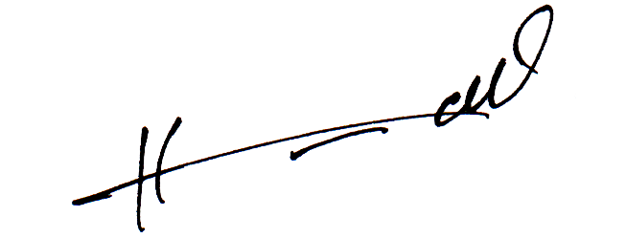

**M/S SWIFCON**

**Engineers & Contractors**